Full day tour to Avignon and Arles

Meet your guide at your hotel or in Avignon, Arles...

Start your trip in Avignon. Located at the confluence of the Rhône and Durance rivers, Avignon is well known for its ramparts, its famous Pont Saint-Bénezet and the Pope’s Palace.
The fortified city of Avignon will not leave you indifferent. Avignon’s architecture is marked by papal history. Home to the Sovereign Pontiffs in the 14th century, the Palace of the Popes is the biggest Gothic palace in the world.

During the afternoon discover the antique town of Arles, the widest city in France.

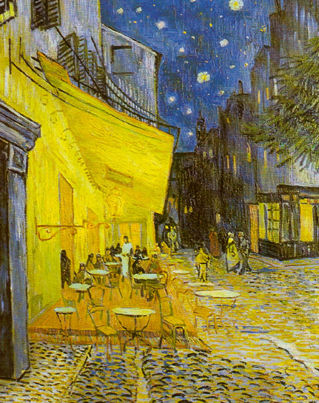
The city’s monuments are listed as UNESCO World heritage and include: The Roman amphitheatre (the arena), the Roman theatre, the Cryptoportico (foundations of the Roman Forum), the cloister and portal of St. Trophime’s and the Alyscamp cemetery.
City of festivals, art, and culture, Arles has never stopped attracting artists. Picasso, a lover of bull fights, was inspired by them and produced two paintings and 57 drawings.
And also Vincent Van Gogh : he discovered the light of the “Midi” (the South of France), and found the inspiration for many of his finest works. Under Provence’s burning sun, he painted scenes of the fields, cypress trees, peasants, and rustic life characteristic of the region.
